Deliverables
Task 1 – Setting up Static IP Address
- Code Snippet
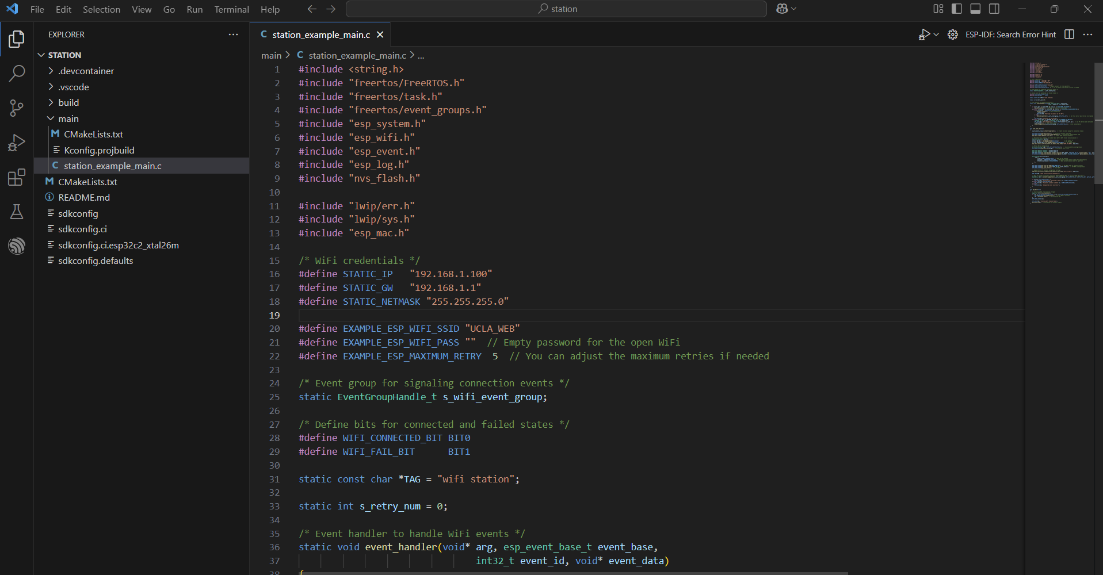
- Evidence of Successful Configured IP Address
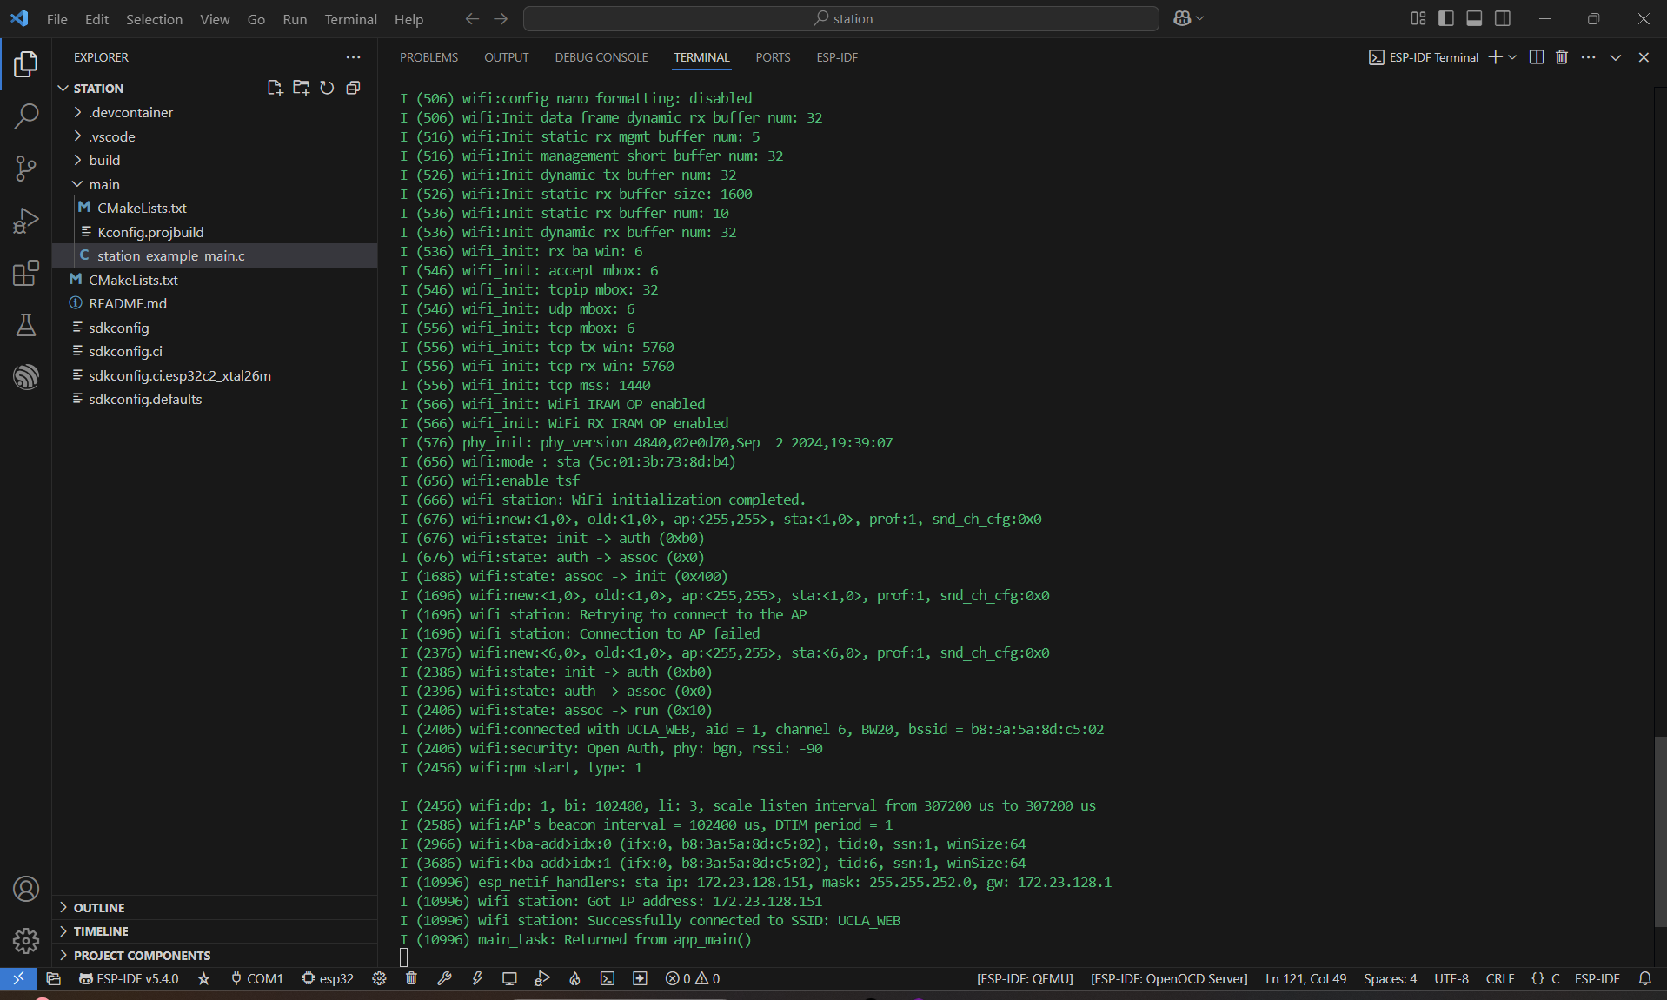
Task 2 – Azure IoT Hub Message Reception from Simulated ESP32
- Code
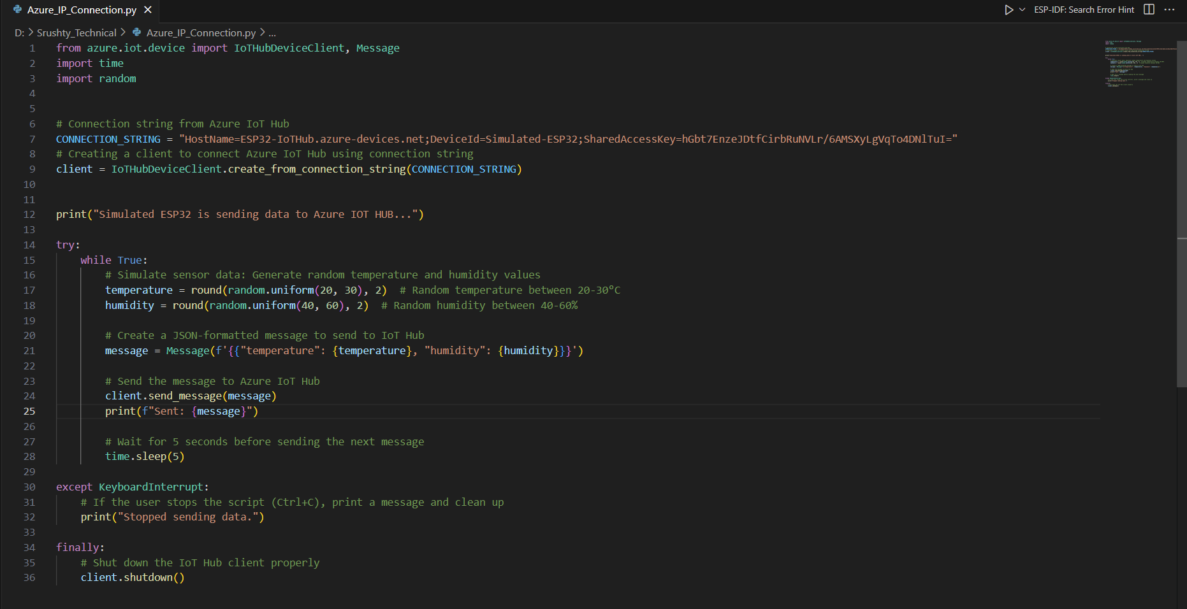
- Evidence of Message Reception
