Reykor – Full function
Purpose
The purpose of this document is to list down the test plan and test setup required to ensure that the slaves is responding to the inputs received from a master

Problem Statement
Test the slaves based on the inputs from the master

Test Setup

Dot board
Two slaves
Master
Power source – regulated power supply
LEDs – 12 for each module
ST Link programmer

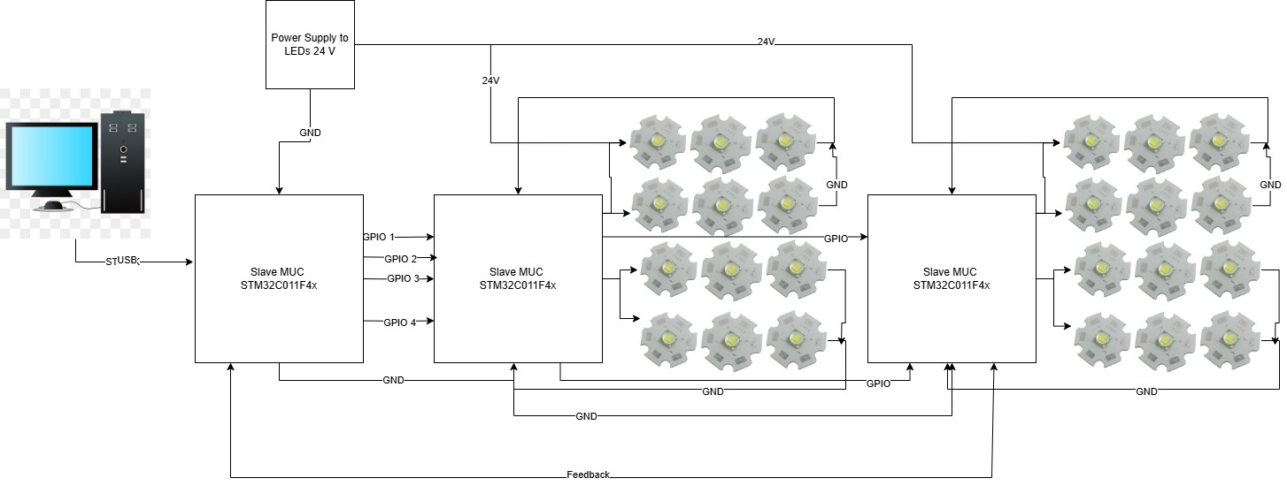
Test Plan

Make connections as per the above diagram, upload the code to the master and slaves. LEDs are connected to the slaves, 12 LEDs for each slave module. Based on the input from master the LEDs should glow and show the sequences.

Expected Result

Slave LEDs should respond to the inputs from the master and when a new input is received from master old state should be turned OFF and new state is turned ON.

Observed Result
Tested with master and one slave, was able to achieve the desired output. When Red flash input is pressed the corresponding LED is flashing, amber flash input is pressed then red LED will stop flashing and amber will start flashing. Left to right LED input button is pressed then the amber LED will flash every two seconds till the next input is received.
Pending : to test the slave to master communication (right to left )

Test video is uploaded on the server.

